10 sparse qubits in a 6x6 quantum dot array

Alexander S. Ivlev¹, Harold Co¹, Damien R. Crielaard¹, Alice Petrillo¹, Setareh Kazemzadeh¹,
Giordano Scappucci¹ and Menno Veldhorst¹
¹ QuTech and Kavli Institute of Nanoscience, Delft University of Technology,
PO Box 5046, 2600 GA Delft, The Netherlands

Spin qubits in gate-defined quantum dots are often seen as a promising candidate for spin-qubit quantum computing given their high achieved control fidelities [1, 2, 3, 4] and their compatibility with advanced semi-conductor manufacturing [5, 6]. Still, device fabrication remains challenging given the small feature-sizes and dense gate-structure required for device operation. As a result, most spin-qubit devices have scaled in one direction [7, 8, 9], with fault-tolerant proposals relying on shuttling to achieve the required connectivity for error correcting codes [10, 11]. Here we take a different approach, pursuing inherit 2D topology by realising a square quantum dot array with 36 plunger gates. This is enabled by using a merged barrier architecture [12], significantly easing the fabrication constraints in our academic cleanroom. While keeping the barrier gate at a single DC voltage, we shuttle spins 4 micrometer to tune and explore this array, mapping out its properties. This way, we coherently reach most quantum dots, allowing us to sparsely populate the array with 10 qubits. We observe that due to this sparsity, our qubits do not experience noticeable crosstalk, achieving beyond threshold single-qubit Clifford fidelities, independent of any drive on other qubits. Finally, by shuttling the qubits into close proximity and using symmetric plunger control [12], we can turn on the exchange between different qubits, this way creating two-qubit entanglement. We show 2Q gates up to 88%, expected to be limited by T2* coherence times.

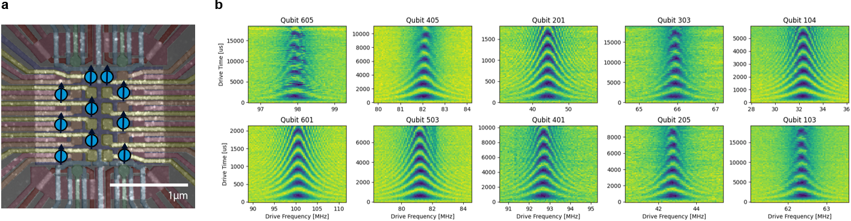
Device and Single Qubit operations. a) AFM figure of 6x6 quantum dot device with 10 qubits in a sparse configuration. b) Chevrons experiments on the 10 qubits.

- Noiri et al., Nature 601, 338-342 (2022)
- Xue et al., Nature 601, 343-347 (2022)
- Mills et al., Science Advances 8, no 14, 5130 (2022)
- Wang et al., Science 385, no. 6706, 447-452 (2024)
- Zwerver et al., Nature Electronics 5, 184-190 (2022)
- Steinacker and Stuyck et al., Nature 646, 81-87 (2025)
- George et al. Nano Letters 25, no 2, 793-799 (2025)
- HRL Quantum Team and Collaborators, arXiv:2604.16216 (2026)
- Dijkema et al. arXiv:2604.01063 (2026)
- Künne et al. Nature Communications 15, 4977 (2024)
- Siegel et al. Physical Review X Quantum 7, 010339 (2026)
- Ivlev and Crielaard et al., Physical Review X, 031042 (2025)

