Magneto-optical properties of the neutral silicon-vacancy center in diamond under extreme isotropic strain fields
Meysam Mohseni^{1,2,3}, Gergő Thiering¹, Adam Gali^{1,3}
¹Wigner Research Centre for Physics, PO. Box 49, H-1525 Budapest, Hungary
²Eötvös Loránd University, Pázmány Péter Sétány 1/A, H-1117 Budapest, Hungary
³Budapest University of Technology and Economics, Institute of Physics, Department of Atomics Physics, Műegyetem rkp. 3., 1111 Budapest, Hungary
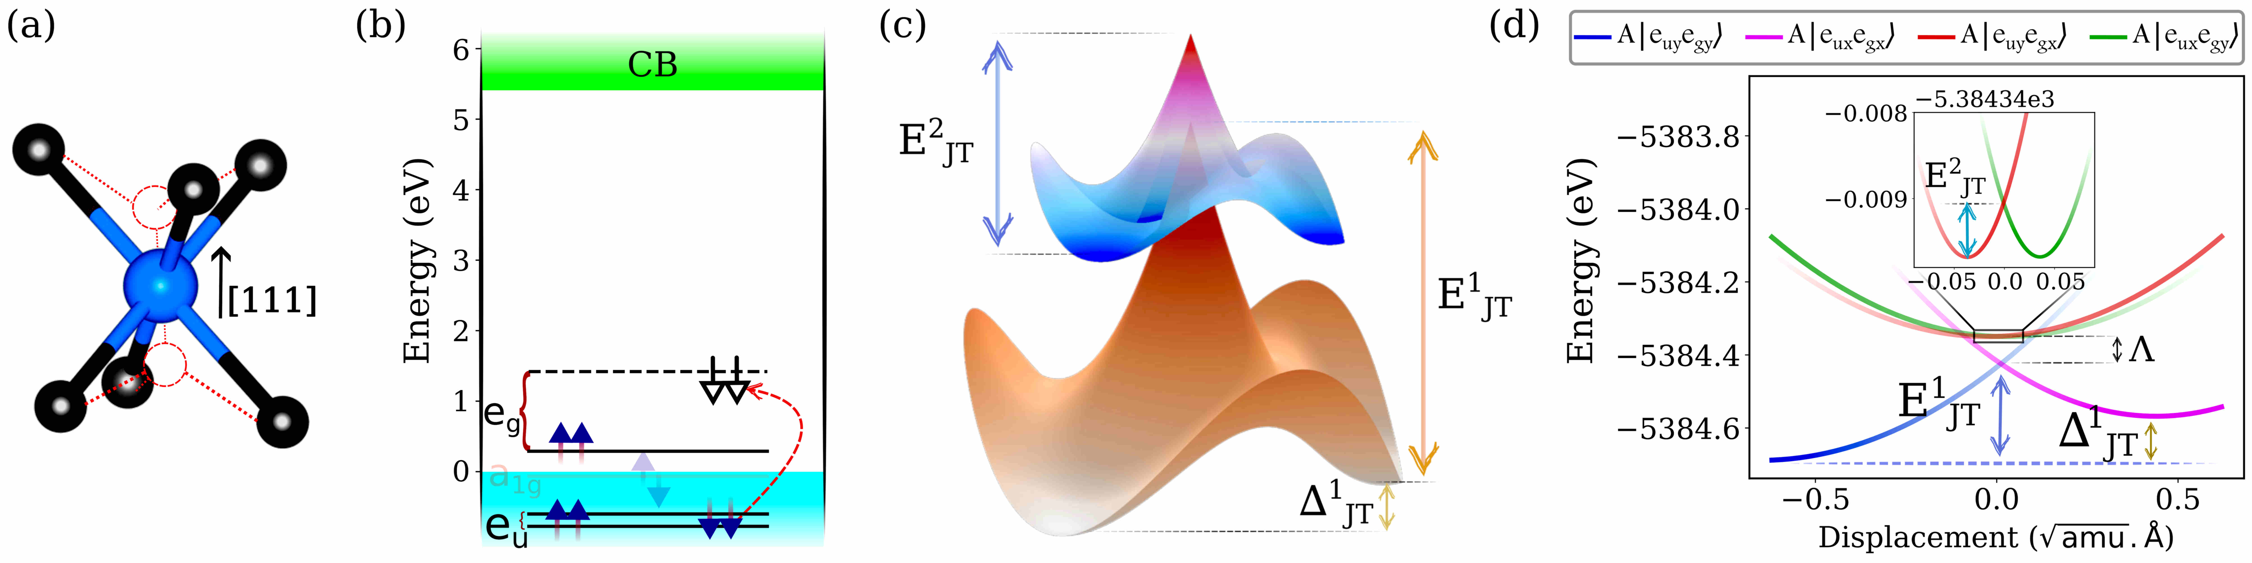
Figure 1. (a) Atomic geometry showing the split-vacancy configuration. (b) Electronic level scheme for the ³A₂g → ³Eᵤ optical transition. (c)-(d) Adiabatic potential energy surfaces and DFT-calculated cuts illustrating the product Jahn-Teller instability and the emergence of symmetry-equivalent energy minima.
The neutral silicon-vacancy (SiV⁰) center in diamond has emerged as a premier candidate for quantum networking and sensing due to its inversion-symmetric D₃d structure [1]. Unlike the polar NV center, the SiV⁰ center is naturally protected from first-order Stark shifts caused by stray electric fields, ensuring stable and indistinguishable optical transitions [2, 3]. Furthermore, it possesses a spin-triplet ground state with millisecond coherence times at temperatures significantly higher than those required for its negatively charged counterpart [1, 4]. Despite these advantages, the defect's electronic structure is governed by a complex product Jahn-Teller (pJT) effect involving the e_g and e_u orbitals, which dictates its fine structure and sensitivity to environmental strain [5, 6]. Understanding how these properties evolve under extreme mechanical deformation is essential for developing robust quantum technologies in high-pressure environments.
In this study, we employ first-principles HSE06 hybrid functional calculations to map the response of the SiV⁰ center to isotropic strain ranging from −80 to 180 GPa. Under hydrostatic compression, the D₃d symmetry remains intact while the E_g phonon modes stiffen, leading to a near-linear blue-shift of the zero-phonon line. This lattice stiffening effectively suppresses the Jahn-Teller instability, causing the Ham-reduced spin-orbit splitting to increase substantially from 25 GHz to approximately 68 GHz and widening the dark-to-bright vibronic gap. In the tensile regime, the system undergoes a structural symmetry breaking to a C₃v configuration beyond 4% strain, characterized by a double-well adiabatic potential. We further identify a regime of tunneling-mediated dynamical averaging at the onset of this distortion. Charge transition level analysis confirms the photostability of the neutral state deep into the compressive regime, whereas extreme tensile stress eventually leads to ionization.
These findings establish the SiV⁰ center as a symmetry-protected, strain-tunable quantum emitter that remains operational even in the multi-megabar pressure range. By providing compact calibration relations that link optical and spin observables to applied isotropic strain, this work facilitates the use of SiV⁰ as a high-precision quantum pressure gauge. Ultimately, our results provide the theoretical framework necessary to engineer diamond nanostructures that can precisely control vibronic coupling and spin-orbit interactions in group-IV vacancy defects.

[1] B. C. Rose et al., Science 361, 60 (2018). | [4] D. D. Sukachev et al., P. R. L. 119, 223602 (2017).
[2] M. W. Doherty et al., Phys. Rep. 528, 1 (2013). | [5] G. Thiering and A. Gali, npj Computational Materials 5, 18 (2019).
[3] L. De Santis et al. Englund, P. R. L. 127, 147402 (2021). | [6] B. L. Green et al., P. R. B 99, 161112(R) (2019).

